2023 Marion Health Rehabilitation Program
Sharing Our Outcomes for 2022

We are extremely proud of the number of our patients who have increased their independence in our inpatient rehabilitation program. Changes in independence are measured using the IRF_PAI Functional Quality Indicators which assess how well patients can manage daily tasks such as dressing, transfers, and walking.

Patient’s functional activities are measured when they arrive (admission) and throughout their stay in inpatient rehabilitation. By the time patients leave the rehab program (discharge), we expect an increase in Functional Gain in the range of 40-50 points. Our overall target is 45. Below is information on the types of patients we see, their length of stay in the program and their functional gains.

Diagnosis  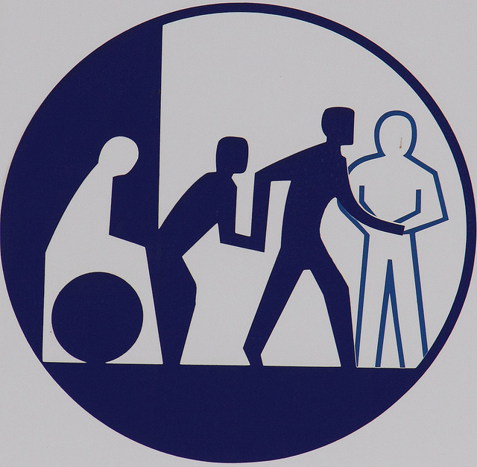 | Number of Those we Served | Average Length of Stay (days) | Discharge Rate to Home or Community Setting | Discharge Rate to Skilled Nursing | Unplanned Transfers to Acute Care | Functional Improvement Gain
Neurological (Neuro) | 41 | 9.4 | 75.6% | 17.1% | 7.3% | 47.9
Stroke | 36 | 14.6 | 86.5% | 8.1% | 2.7% | 54.2
Debility | 23 | 8.8 | 91.7% | 4.2% | 0% | 56
Nontraumatic Brain | 20 | 8.6 | 95% | 0% | 5% | 44
Cardiac | 18 | 9.2 | 88.9% | 11.1% | 0% | 43.4
Fracture of lower extremity (LE) | 15 | 13.3 | 66.7% | 26.7% | 6.7% | 51.4
Other Ortho | 11 | 9.2 | 72.7% | 27.3% | 0% | 36.2
Replacement of LE | 8 | 8.9 | 100% | 0% | 0% | 43.6
Amputation | 5 | 7.6 | 80% | 20% | 0% | 43.6
NT Spinal Cord | 4 | 12.8 | 100% | 0% | 0% | 39.1
Pulmonary | 3 | 10.0 | 100% | 0% | 0% | 44.3
Major Multiple Trauma without Brain or Spine | 3 | 11.0 | 100% | 0% | 0% | 76
Guillain Barre | 2 | 25.5 | 50% | 50% | 0% | 36.5
Major Multiple Trauma with Brain and Spine | 1 | 36.0 | 100% | 0% | 0% | 76
All Diagnosis | 192 | 10.8 | 84.4% | 11.5% | 3.1% | 49.8
 | Total Patients Served | Average Age | % Male | % Female | Average Number of Treatment Hours/Day | Patient Satisfaction with Services
All Patients & All Diagnoses | 192 | 73.7 | 43.2% | 56.8% | 3.0

Of the 192 patients served here in 2022, the overall functional gain attained was 49.8 which is above the expected overall target of 45.

Patient Satisfaction:
Patients who responded to our survey consistently rated our services at _________ for overall Patient Satisfaction. Our survey response rate is ________%

Our greatest achievements are in preparing our patients to return home or to a community setting, 84.38% achieved this successfully!

Marion Health Rehabilitation Program Individualized Information & Disclosure
YOUR CARE:
Your program will include individualized frequency and intervention by the following disciplines. An approximate plan will include:

- PT: _____minutes per day for strengthening, balance, and mobility
- OT: _____minutes per day for self-care skills such as bathing, dressing, grooming, & eating
- ST: _____minutes per day for difficulties in thought processes, swallowing and/or speaking

A combination of these services will be provided at least 3 hours per day, usually in the morning and afternoon. Lunch and rest period are at mid-day. Based on your needs, you may receive additional therapy on the weekends. In addition, other therapeutic services may include recreation activities and educational classes.

You will be seen by a physician specializing in Rehabilitation Medicine. The hospital
has 24-hour physician on call coverage and consulting specialists are available if needed. Rehabilitation Nursing will also be provided around the clock.

Your estimated length of stay at Marion Health will be ___days.

Alternative Resources:
Your discharge from rehabilitation will be facilitated by your case manager who will help identify and arrange for any individualized services that may be required upon discharge. These may include:
- Durable medical equipment (DME) and Prosthetics and orthotics
- Skilled nursing facilities where therapy at a less intense level is offered with 24 hour nursing care.
- Home health services, outpatient services, caregiver services
- Counseling for depression, adaptation to disability, substance use, and other needs
- Support groups / peer support

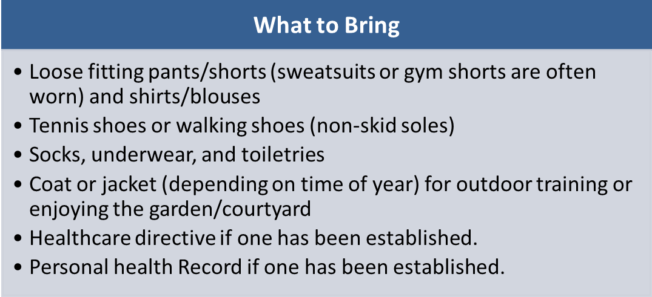

Visiting Hours:
Since a large portion of the day is spent in therapy, visiting hours are tailored to allow for uninterrupted sessions with limited distractions. General visiting hours are 4 p.m. to 8:30 p.m. Monday through Friday, and noon to 8:30 p.m. on weekends and holidays. A primary caregiver may stay with the patient around the clock and will observe and /or be involved in therapy on scheduled days. There are no age restrictions for visitors. Please note that during the COVID pandemic, visiting hours may be limited or even restricted.

Your hospitalization costs may be covered by:
Medicare Part A: Pays for the cost of inpatient rehabilitation provided you meet criteria at admission and during your stay. Your out-of-pocket expenses include a deductible for inpatient hospital stays and daily coinsurance for continuous inpatient stays lasting longer than (60) days, (61st through 150th day). For more specific coverage, visit Medicare’s website at www.CMS.hhs.gov or ask to speak with your case manager. Your rehabilitation stay at this facility will be covered under the hospital level benefit. The Medical Director will make the decision whether you meet admission criteria, but it is always subject to review from Medicare.
Currently you have ___ Medicare days at 100%, ___days at 80% and ___ lifetime days available.
Indiana Medicaid: If approved, Medicaid will cover many medically necessary services. Since there may be different levels of coverage depending upon financial qualifications, you will need to contact the State Medicaid Office to determine if any coverage limitations apply to you.
Private Insurance/Indemnity/Medicare Supplement/ HMO/PPO/Managed Medicaid/Worker’s Compensation / etc.: As a courtesy to you, we will usually call a representative from your insurance plan and try to determine whether the services you are seeking will be covered. Benefits will be verified prior to admission and a designated staff member will obtain pre-authorization if required. You will need to inquire about benefits for inpatient rehabilitation at a hospital level of care. Throughout your stay, as required, your case manager will work with your insurance to obtain continued authorization. If requested, a financial counselor is available to assist you and your family in understanding your benefits, co-payments, and responsibilities.

Insurance: ____________________________Phone Number: _______________
Verification has been obtained, and you have ____________ authorized days. Co-pay information is as follows: ______________________.
This is not a guarantee of payment or of the coverage your plan will provide. We make every effort to obtain accurate information, but you should contact your provider representative to personally verify your coverage.
The Marion Health Rehabilitation Unit Information and Disclosure document has been provided to you for general informational purposes.

Signature: ______________________________________Date: _______________

Inpatient Rehabilitation Program at Marion Health
Program Information for 2023
Welcome to Marion Health. Our 18-bed acute inpatient rehabilitation unit is designed to meet your medical needs through expert rehabilitation care. With the help of our rehabilitation team and the support of your family and other loved ones, you will develop new skills and re-learn previous skills that were affected by illness or injury.
We will work closely with you and your family during your stay here with the goal of sending you home or to the most appropriate placement. To help you recover as fully as possible, it is important for you and your family to understand our rehabilitation program and your treatment.
This guide explains our services and provides information on the types of patients we serve. It also includes details of your individual treatment and payment information that will help you understand what to expect while you are in our rehabilitation program and when you are ready to go home. Your feedback is one of the keys to our success and your recovery. Please share with us how we can make your rehabilitation stay as meaningful and rewarding as possible.

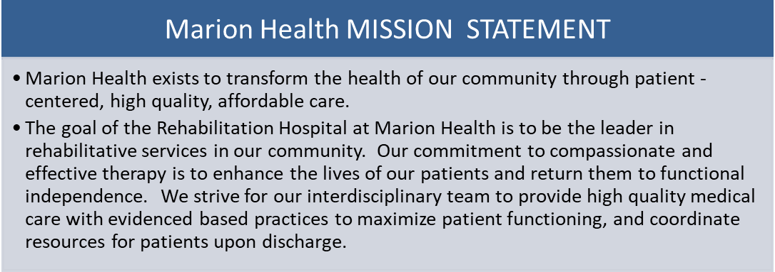

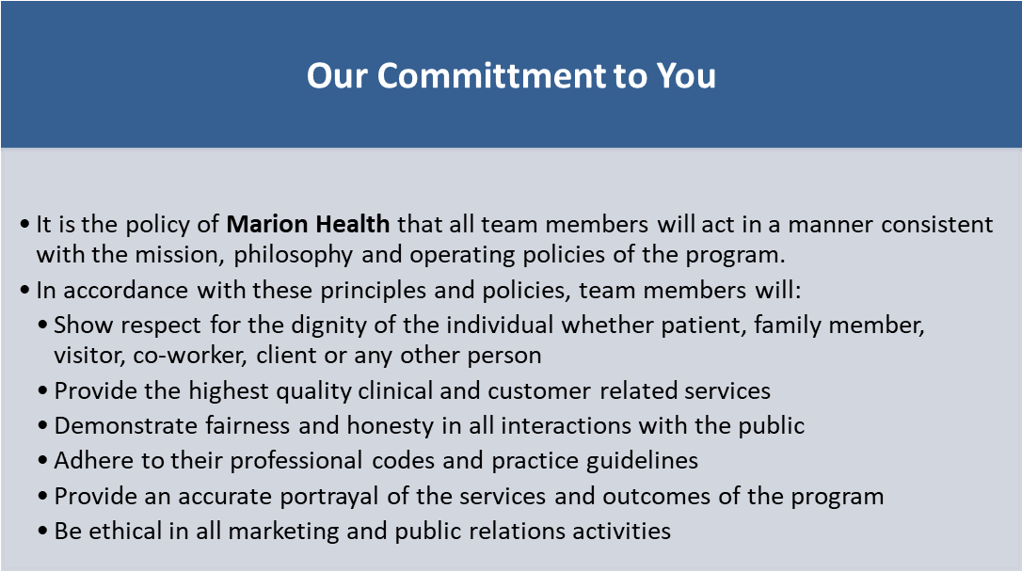

Referral Sources: We receive referrals from the geographic area of Indiana from the surrounding acute hospitals, long term acute care hospitals (LTACH), skilled nursing facilities, home health agencies, outpatient centers, physicians as well as self-referrals.
Methods Used to Assess and Meet Patient Needs: We perform a pre-admission screening prior to admission to assess your status and your goals when you leave our program. It is important to understand each patient's medical, physical, and mental condition, as well as any restrictions (social or cultural), to develop the best treatment plan.
A patient’s psychological status is also considered when determining whether he or she could benefit from admission. The rehabilitation Medical Director on our unit will review the pre-admission assessment to decide to approve or deny the referral prior to admission and the decision will be communicated to the referral source, patient, and family/support system. If referral is determined to be ineligible, recommendations will be made for alternative services.

Conditions Treated:
The rehabilitation program serves patients with a variety of medical, physical, and functional needs. Some of the conditions treated in the program include:
- Stroke
- Spinal Cord Injury
- Amputation
- Brain Injury
- Guillain-Barre
- Hip Fractures
- Joint Replacements
- Multiple Trauma
- Cardiac or Pulmonary Disorders
- Myopathy
- Progressive or Degenerative Neurological Disorders:
  - Multiple Sclerosis
  - Muscular Dystrophy
  - Parkinson’s’ Disease

Admission and Continued Stay Criteria:
- Patient must be medically stable
- Patient must be able to tolerate an intensive rehabilitation therapy program consisting of three hours of therapy per day at least five days per week or consist of at least 15 hours of intensive rehabilitation therapy within a seven consecutive day period, beginning with the date of admission
- Nursing care must be required 24 hours a day
- Patient must require two or more therapies, one of which will be physical or occupational therapy, as well as a coordinated interdisciplinary approach to his or her rehabilitation
- Patient must have experienced a functional decline
- Patient must have potential for improvement
- Patient must be cooperative and motivated
- Patient must require supervision by a rehabilitation physician to assess the patient both medically and functionally and to change the course of treatment if necessary.
- Patient must have a payment source or an arrangement with our financial department prior to admission

Discharge and Transition Criteria:
Our team works with you, the patient, and your family to ensure the most appropriate placement following discharge from acute rehabilitation. When the patient’s medical condition allows, the patient and family will be notified as soon as possible in advance of the pending discharge by the Acute Rehabilitation Case Manager. Discharge from the program shall be considered when one or more of the following criteria occur:
- A patient has reached his/her rehabilitation potential and no longer warrants the intensity of therapy services
- A patient makes no progress in any area of therapy in more than one week
- A patient is medically unstable requiring more intensive medical intervention
- A patient is behaviorally unable to cooperate with the demands of the program or is jeopardizing his/her own safety or that of other patients or staff
- A patient refuses to participate in the program for 72 hours, despite being medically stable, and there is no evidence of progress.

Non-Voluntary Discharge:
- If you are unable to complete your rehabilitation program because of the intensity of the services, which includes a minimum of three hours of combined therapy at least five days per week, our case manager will assist in finding placement in a less intensive setting to continue services.

Services Provided: (All services provided directly unless noted to be by contract or referral)
- Rehabilitation Medicine | - Activity Programs | - Respiratory Services
- Medical Consults (referral) | - Social Work/Case Management | - Dietary Services- Nutrition
- Rehabilitation Nursing  - Physical Therapy  - Occupational Therapy  - Speech Language  Pathology | - Orthotics / Prosthetics  - Visual Assessment (referral)  - Driver Rehabilitation (referral) | - Wound Care  - Chaplaincy  - Home Evaluations
Medical, diagnostic, laboratory, and pharmacy services are also available at Marion Health Hospital. The response time is specific to each of these services per hospital policy.
Lab services: stat turnaround within 2 hours. All other labs, 24 hours turn around.
Pharmacy services: are provided by the hospital 24 hours/day.
Medical procedures and diagnostic testing are scheduled based on need and priority with most services scheduled within 24 – 48 hours with results provided with 24 hours from test time.

OUR SERVICES
Comprehensive acute inpatient rehabilitation services are provided to adult patients with neurological and other medical conditions who have experienced a loss of function in activities of daily living, mobility, cognition, or communication. This program serves persons 18 years and older and is open to people of all cultures and from all payer sources. Our patients have an illness or injury that requires an ongoing hospital stay but are stable enough to undergo therapy.

Persons served will receive 24-hour rehabilitation nursing and a minimum of three hours a day of therapy a day, no less than five out of seven days in the week. Your therapy program, including the frequency, intensity, and length of stay, will be designed according to your needs after you have been fully evaluated. Hours for therapy services are normally provided from 7:00 am to 4:00 pm.
When you complete your rehabilitation program, the team will work with you and your family to help determine if it is safe for you to return home. If you are unable to return home after discharge, the team will assist you and your family in making other arrangements.

Restrictions of our Program:
Our program does not accommodate anyone under the age of 18, ventilator-dependent patients (c-pap and bi-pap machine set to vent settings during sleep are allowed), patients who are non-responsive or unable to follow commands, those who have severe dementia, patients who wander excessively, are combative or have behavioral dysfunctions. We cannot serve patients with spinal cord injuries at C5 or higher without physician clearance, but can treat injuries below that level, whether complete or incomplete, traumatic, or non-traumatic. We do not accept patients with severe burns, or those who have unstable labs. If our services are unable to meet the needs of a patient referred, recommendations for alternate services will be provided.

Insurance and Payment Sources:
Medicare and your supplemental secondary insurance (if you have one) will cover most services provided during your inpatient rehabilitation stay if you meet the admission and continued stay criteria. The Medical Director will evaluate whether you meet these criteria, but this is always subject to Medicare review. If you have other types of insurance, your benefits will be verified before admission. If there are limitations identified in your coverage, your case manager will discuss these with you, as well as alternative resources to help meet your needs.
Out-of-pocket expenses that you may incur depend upon your specific insurance coverage, co-payments, benefits, and eligibility. Some patients may need to purchase durable medical equipment (wheelchair, walker, commode, etc.) as this equipment may not be covered by a particular insurance plan.

Assistance with Financial Responsibility:
A financial counselor is available to assist you and your family in understanding your benefits, co-payments, and responsibilities before or after admission. If you are paying cash or need assistance or information, please contact your case manager.
Your rehabilitation team is an interdisciplinary team with specialists in stroke rehabilitation that put you at the center of the team. Your specialists include:
- Physicians to manage rehab and complex medical needs around the clock
- Rehab nurses to provide 24-hour care
- Physical therapists, Occupational therapists, and speech therapists
- Dietician
- Case manager / social worker
- Respiratory therapists
- Chaplain
- Prosthetics / orthotics
The individualized program provides a holistic approach to assist with:
- Improving functional mobility and self-care skills
- Building strength and improving balance
- Improving speech and swallowing and developing strategies to compensate for deficits
- Improving cognition and developing strategies to compensate for any deficits
- Psychological and social coping and adaptation skills
- Integration in the community
- Providing resources to meet ongoing medical, physical, psychological, social, and adaptation needs.
Education for patients and families includes education classes, a Stroke Support group, individualized training, peer support, and written materials to include topics such as:
- Preventing and/or minimizing secondary complications
- Mobility and self-care
- Physical, emotional, and social effects of stroke
- Nutrition, exercise, health & well-being
- Medication management and access
- Home safety, modifications, adaptive equipment, and minimizing environmental barriers
- Access to community resources and funding

General Information:
Discharge against Medical Advice (AMA): Competent patients, and those with legal guardians or active durable power of attorney for health care, have the right to leave the hospital against medical advice. In that event, the physician will inform the patient of the potential risks. The patient, guardian, or durable power of attorney for healthcare will then sign a release of liability for leaving against medical advice.

Security of Personal Possessions: Patients are encouraged to leave valuables at home. The hospital cannot be responsible for lost or stolen items. If such items are brought with the patient, he/she is encouraged to have nursing staff place them in the safe located in the business office, during business hours.

Patient Rights: The persons served, families, friends, caregivers and community have the right to respectful, considerate care from all rehabilitation members they interact with at all times and under all circumstances. All individuals served will have freedom from abuse, financial exploitation, retaliation, humiliation, and neglect. We do not discriminate based on race, ethnicity, national origin (including language), spiritual beliefs, gender, age, current mental or physical disability, sexual orientation, or socioeconomic status. A copy of Patient Rights is available, as well as posted for viewing on the unit.

Rights with Regard to Advanced Directives: Our case manager will assist in providing information regarding Advanced Directives.

Current Accreditations

Accreditation Commission for Health Care

INCLUDEPICTURE "cid:image005.jpg@01D55CEB.D340B1C0" \* MERGEFORMATINET INCLUDEPICTURE "cid:image005.jpg@01D55CEB.D340B1C0" \* MERGEFORMATINET INCLUDEPICTURE "cid:image005.jpg@01D55CEB.D340B1C0" \* MERGEFORMATINET INCLUDEPICTURE "cid:image005.jpg@01D55CEB.D340B1C0" \* MERGEFORMATINET INCLUDEPICTURE "cid:image005.jpg@01D55CEB.D340B1C0" \* MERGEFORMATINET INCLUDEPICTURE "cid:image005.jpg@01D55CEB.D340B1C0" \* MERGEFORMATINET INCLUDEPICTURE "cid:image005.jpg@01D55CEB.D340B1C0" \* MERGEFORMATINET 

Commission on Accreditation of Rehabilitation Facilities (CARF)

If there is a need for any clarification regarding the plan of care, please notify any staff member. If you have any questions or concerns regarding the program OR if you are not satisfied with your care, please ask to speak to a manager or the director. (If you have concerns that cannot be resolved, we can provide you a copy of our Grievance policy and assist you with the grievance process.)

If you have questions or concerns, please call:
Ann Miller, M.A. CCC-SLP, MBA, MRMC
Program Director
Rehabilitation Hospital of Marion Health
765-660-6361

